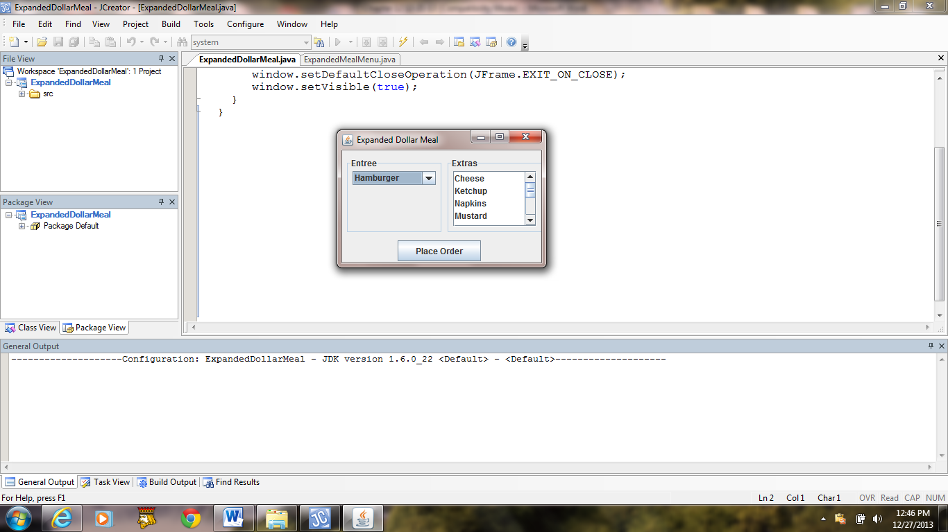 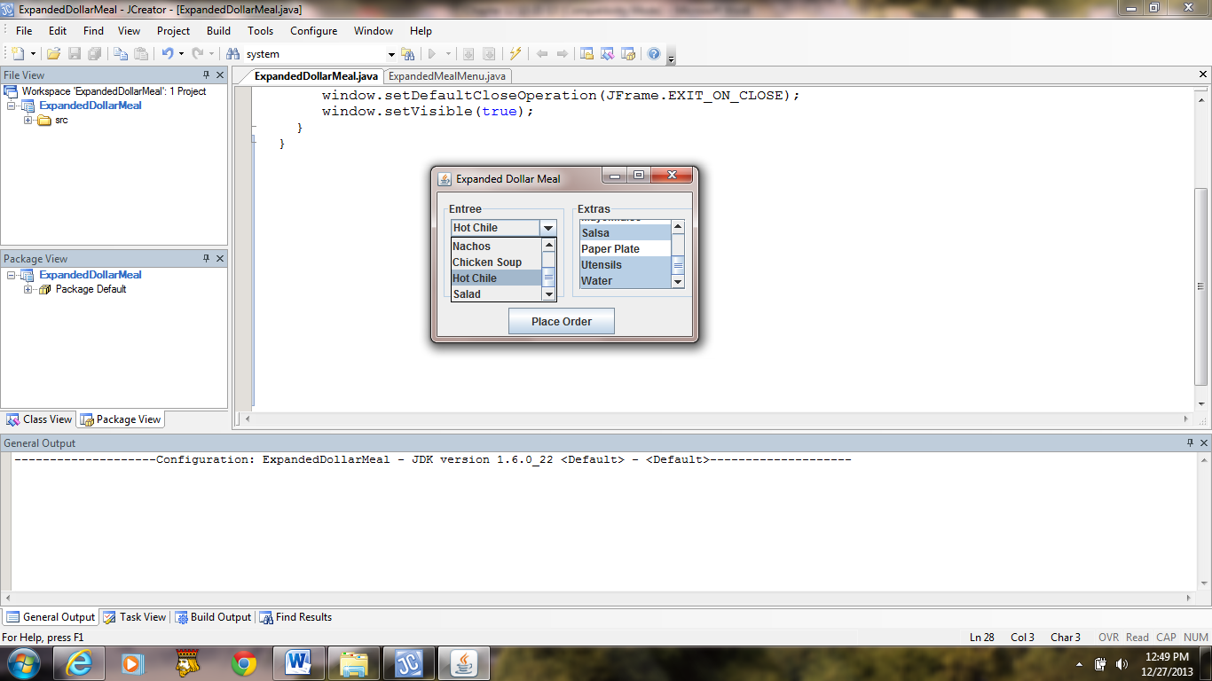

a) b)

*Console Output:*

Entree Number 5: Hot Chili, Salsa, Utensils, Water

**Figure 12.9 The GUI of the application ExpandedDollarMeal and a user input and corresponding console output.**